Traffic Monitoring System

Objective:

The main objective of this project is to design and implement a real-time traffic monitoring system to assist commuters in making optimal route decisions and to contribute to improving traffic flow. The system will utilize IoT sensors, Raspberry Pi, and a mobile application to provide real-time traffic data.

IoT Sensor Setup:

Traffic Flow Sensors: Utilize infrared sensors or cameras at strategic locations to detect and monitor the flow of vehicles.

The IoT sensor setup for this project will include the following:

* Ultrasonic sensors to detect vehicles and measure traffic density
* Inductive loop sensors to detect the presence of vehicles at intersections
* CCTV cameras to monitor traffic conditions and identify incidents
* Weather Sensors: Implement weather monitoring sensors to account for weather conditions affecting traffic.

Components Required:

* Arduino board (e.g., Arduino Uno)
* Ultrasonic distance sensor (HC-SR04)
* Breadboard and jumper wires
* (Optional) Display device (LCD, serial monitor, etc.)

Raspberry Pi Integration:

• Raspberry Pi serves as the main controller and data aggregator for the IoT sensors. It collects, processes, and transmits data to the cloud or server.

Hardware Setup:

Utilize a Raspberry Pi as the central processing unit for data aggregation and processing.

Connect sensors to the Raspberry Pi for data input.

Software Implementation:

Write software in Python to interpret and process data received from the sensors.

Develop code to analyze traffic density, vehicle speed, and other relevant parameters.

Implement communication protocols to receive and process data from sensors.

Mobile App Development:

• User Interface: Create an intuitive mobile application to display real-time traffic conditions, suggested routes, and alerts for commuters.

• Features: Include a map view displaying traffic congestion, alternate routes, estimated travel times, and weather updates.

Platform Selection and Frameworks:

Choose the platform (iOS/Android) for app development.

Use appropriate frameworks and languages (e.g., Java/Kotlin for Android, Swift for iOS).

App Features:

Implement real-time traffic data visualization.

Use GPS to identify user location.

Display traffic information and suggest optimal routes based on real-time data.

User Interface (UI) and User Experience (UX):

Design an intuitive and user-friendly interface for easy interpretation of traffic data.

Provide clear route suggestions and real-time updates.

Diagram and Schematics:

• Create schematic diagrams of the IoT sensor setup, including the placement of sensors in traffic areas and their connection to the Raspberry Pi.

• Illustrate the system architecture, showing how data flows from sensors to the Raspberry Pi and to the mobile app.

Code Implementation:

• Provide sample code snippets or pseudocode for the Raspberry Pi to collect and process data from sensors.

* Python: For developing the backend server and mobile app
* OpenCV: For image processing and video analysis
* TensorFlow: For machine learning-based traffic prediction

• Outline the code structure for the mobile app, including functions for data display and route suggestions.

Write code to enable communication between sensors and the Raspberry Pi.

Ensure data transmission and reception protocols are robust and reliable.

Raspberry Pi - Mobile App Communication:

Develop the necessary APIs or communication protocols for data transfer from the Raspberry Pi to the mobile app.

Design the data format and transmission methods for the app to receive and process real-time traffic updates.

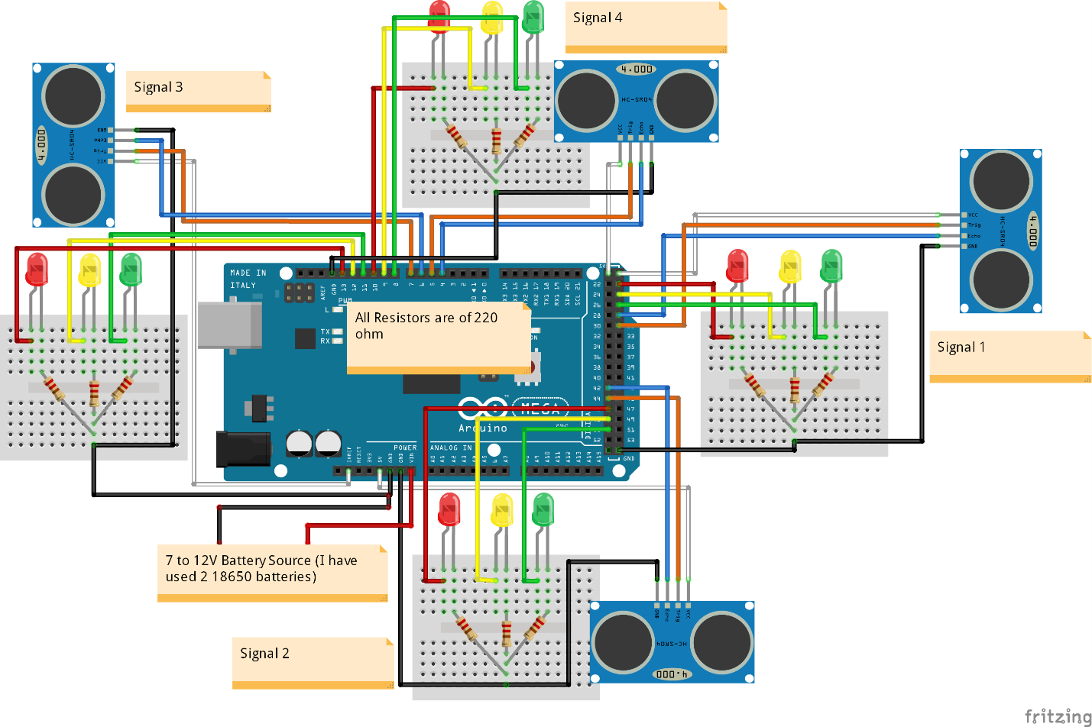

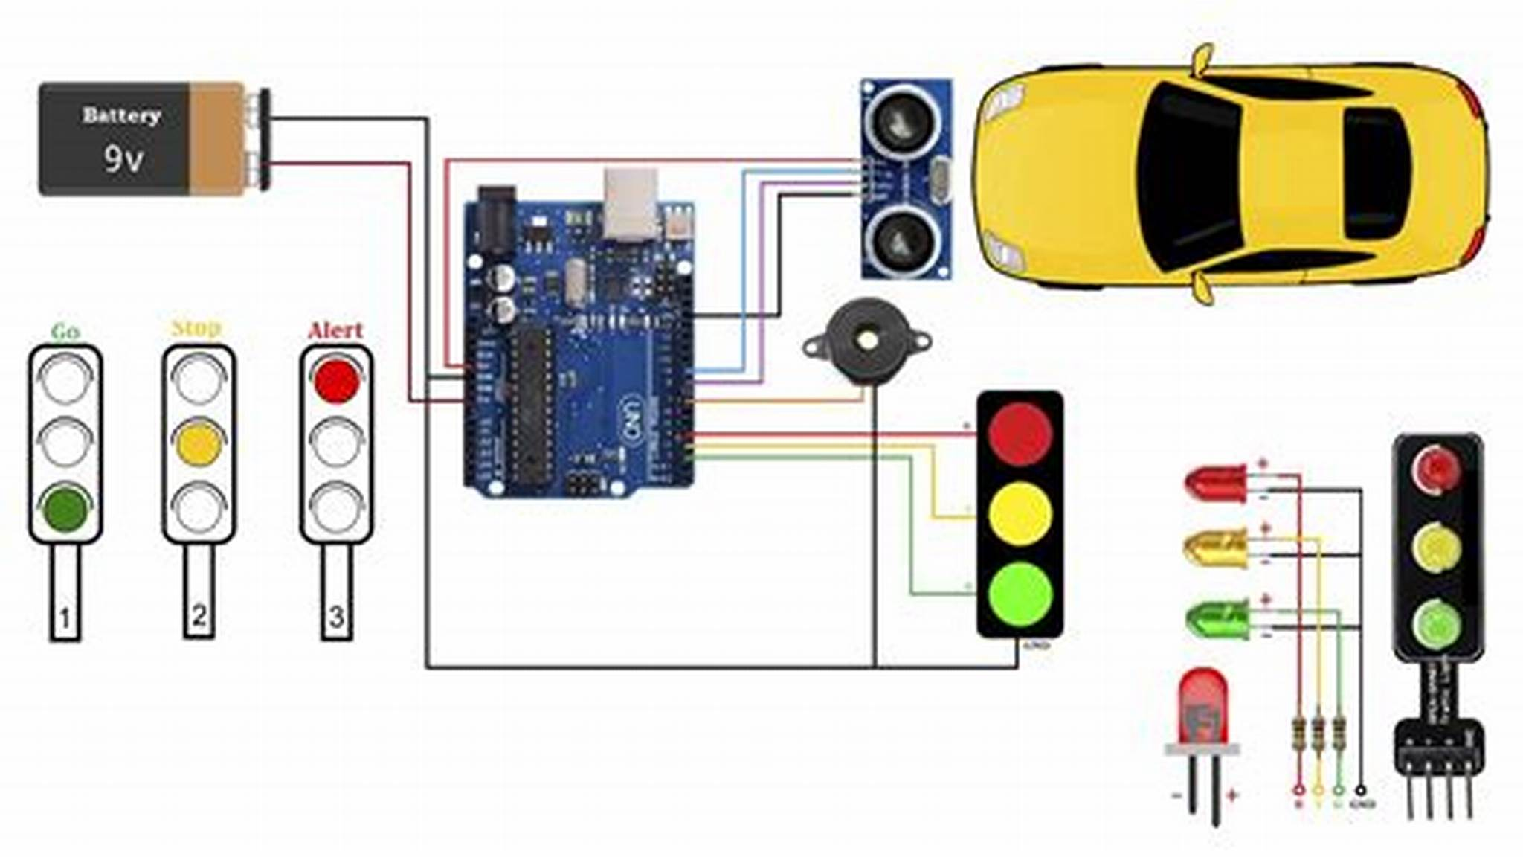

Sensor Data Collection (Python - Raspberry Pi):

# Example code for reading data from an infrared sensor connected to Raspberry Pi GPIO

import RPi.GPIO as GPIO

GPIO.setmode(GPIO.BCM)

GPIO.setup(sensor_pin, GPIO.IN)

# Function to read sensor data

def read_sensor():

if GPIO.input(sensor_pin):

return 1 # Traffic detected

else:

return 0 # No traffic

# Continuously read sensor data

while True:

traffic_status = read_sensor()

# Send data to data processing and analysis functions

Data Processing and Analysis (Python - Raspberry Pi):

# Analyze and process sensor data

def process_data(traffic_status):

# Implement data analysis logic (e.g., count vehicles, measure traffic density, etc.)

# Process and prepare the data for transmission to the mobile app

return analyzed_data

Communication between Raspberry Pi and Mobile App (Python for Raspberry Pi API, Java/Kotlin for Android, Swift for iOS):

from flask import Flask, request, jsonify

app = Flask(__name__)

# Route to receive data from Raspberry Pi

@app.route('/traffic_data', methods=['POST'])

def receive_traffic_data():

data = request.get_json()

# Process data received from the sensors

processed_data = process_data(data)

# Send processed data to mobile app

# ...

return jsonify({"status": "Data received successfully"})

if __name__ == '__main__':

app.run(host='0.0.0.0', port=5000)

Arduino code :

// Libraries for Ultrasonic Sensor

#include <NewPing.h>

#define TRIGGER_PIN 12 // Arduino pin connected to the sensor's trigger pin

#define ECHO_PIN 11 // Arduino pin connected to the sensor's echo pin

#define MAX_DISTANCE 200 // Maximum distance (in centimeters) for the sensor

NewPing sonar(TRIGGER_PIN, ECHO_PIN, MAX_DISTANCE);

void setup() {

Serial.begin(9600); // Initialize serial communication

}

void loop() {

delay(100); // Delay for sensor stability

unsigned int distance = sonar.ping_cm(); // Get distance from the ultrasonic sensor in cm

if (distance > 0 && distance < MAX_DISTANCE) {

// Calculate and display traffic density based on distance measured

int density = map(distance, 0, MAX_DISTANCE, 100, 0); // Mapping distance to density (0 to 100 scale)

Serial.print("Traffic Density: ");

Serial.print(density);

Serial.println("%");

// Perform actions based on the traffic density (e.g., display on an LCD or LED)

// Example: if (density > 70) { /* Take action */ }

} else {

Serial.println("No object detected!");

}

}

Real-time Traffic Monitoring and Commuter Assistance:

The system's real-time traffic monitoring capabilities assist commuters in the following ways:

1. Optimal Route Decisions: Commuters can access real-time traffic information through the mobile app, enabling them to choose the most efficient route based on current traffic conditions.

2. Alternate Route Suggestions: The app will suggest alternative routes in case of traffic congestion, accidents, or road closures.

3. Weather Updates: Integrating weather data allows users to consider weather conditions and their impact on traffic flow, thereby making informed decisions.

4. Improving Traffic Flow: By efficiently distributing traffic across multiple routes, the system aids in reducing congestion on commonly used roads, thereby improving overall traffic flow.

Optimal Route Decisions: The mobile app provides users with updated traffic information, enabling them to select the best routes based on real-time data.

Time Efficiency: Users avoid traffic congestion, saving time by choosing less congested routes.

Improved Traffic Flow: The system helps distribute traffic by suggesting alternative routes, thereby reducing congestion and enhancing overall traffic flow.

In the project document, it's crucial to detail the technical specifications, budget, a timeline for development, and any potential challenges or risks associated with implementation.

Please note that for the visual elements, you'd need to create diagrams, schematics, and screenshots using appropriate software tools like Lucidchart, Fritzing, or any preferred design software. Incorporate these visuals into your project document to enhance its comprehensiveness and visual appeal.

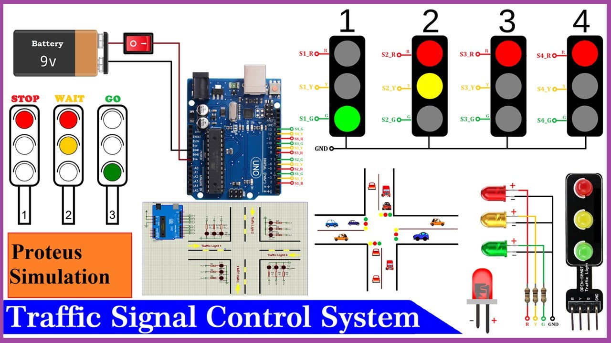

Conclusion:

The real-time traffic monitoring system is a valuable tool for both commuters and traffic authorities. It can help to improve traffic flow, reduce congestion, and make it easier for people to get around.